Test Case: runTestMultipleTimes
Step 1 - Enter username and password and click to button Enter : Credentials Entered
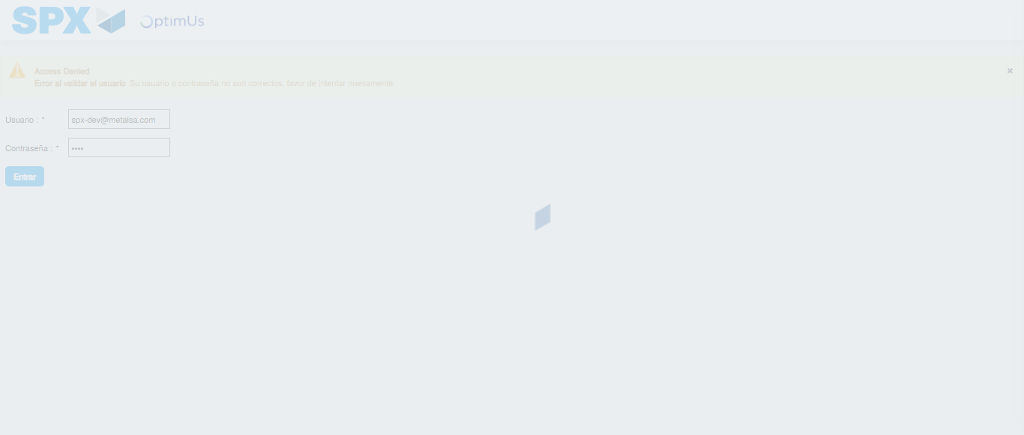Image file-name: QC_Testing-runTestMultipleTimes-dic. 04 2025, 03 38 08 p. m.

Step 2 - Select to UEN and Access to Administrador Roles Menu: UEN Correctly selected and Correct access
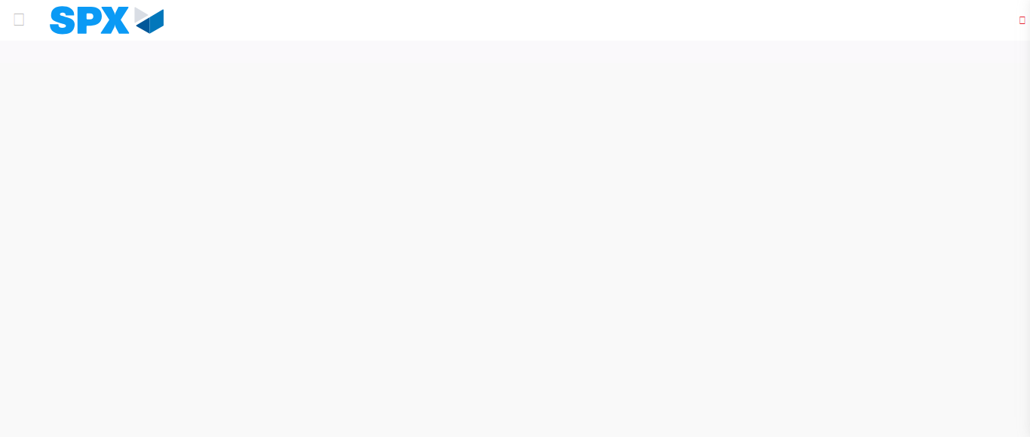Image file-name: QC_Testing-runTestMultipleTimes-dic. 04 2025, 03 38 13 p. m.

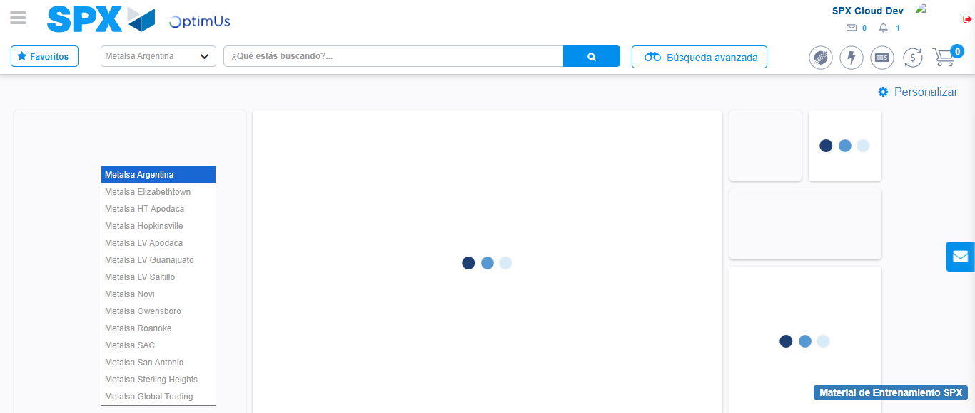Image file-name: QC_Testing-runTestMultipleTimes-dic. 04 2025, 03 38 14 p. m.

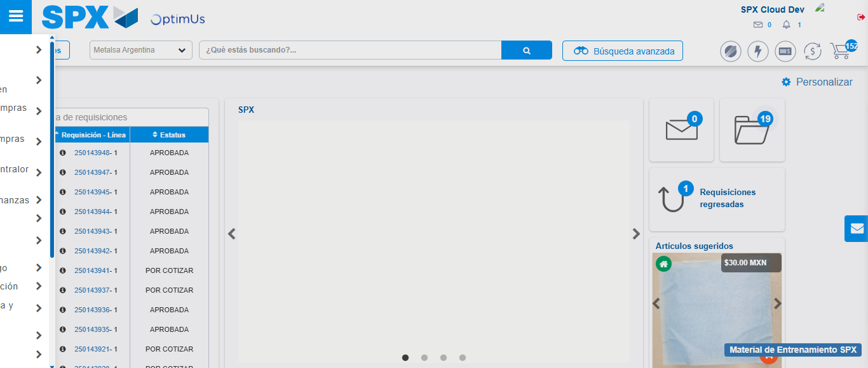Image file-name: QC_Testing-runTestMultipleTimes-dic. 04 2025, 03 38 15 p. m.

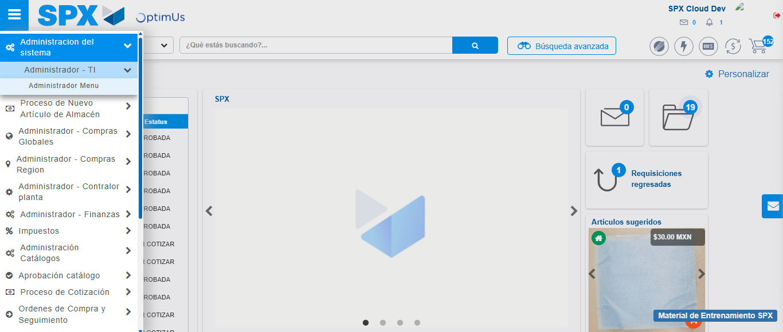Image file-name: QC_Testing-runTestMultipleTimes-dic. 04 2025, 03 38 16 p. m.

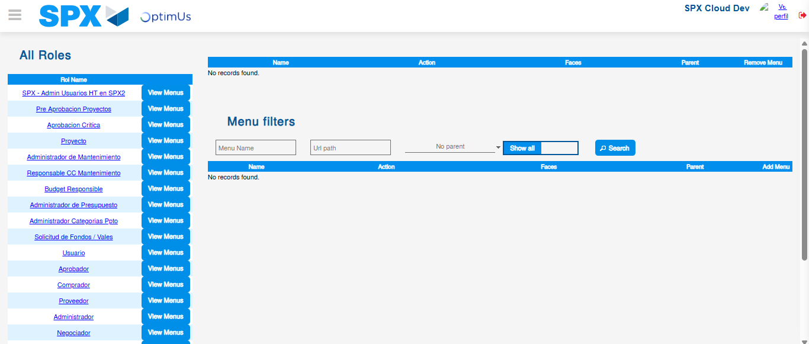Image file-name: QC_Testing-runTestMultipleTimes-dic. 04 2025, 03 38 20 p. m.

Step 3 - Click to Buttons View Menu and Search Filter with Menu Name: Correct Search
Image file-name: QC_Testing-runTestMultipleTimes-dic. 04 2025, 03 38 20 p. m.

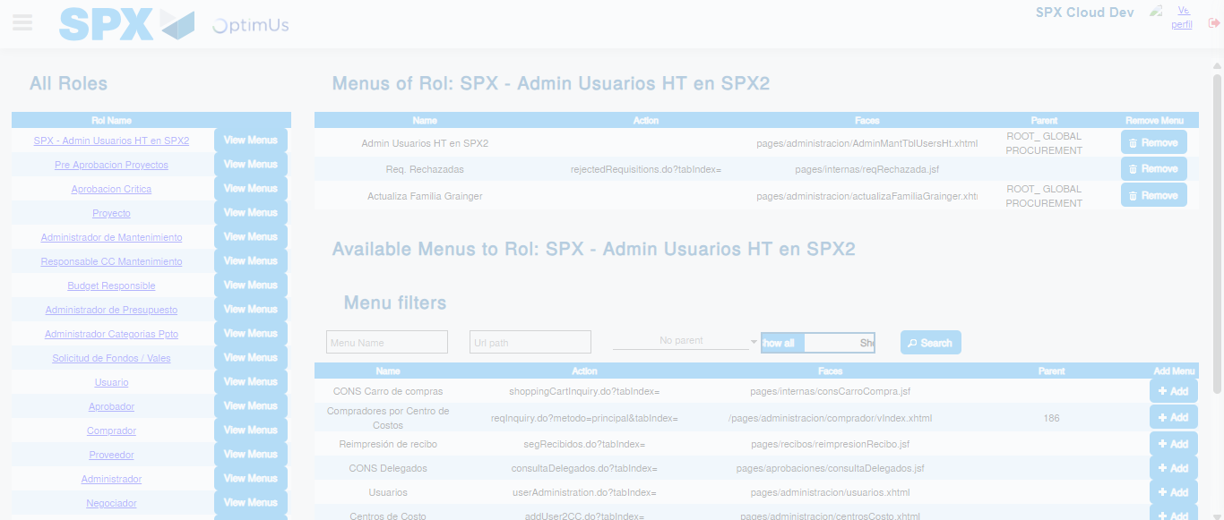Image file-name: QC_Testing-runTestMultipleTimes-dic. 04 2025, 03 38 21 p. m.

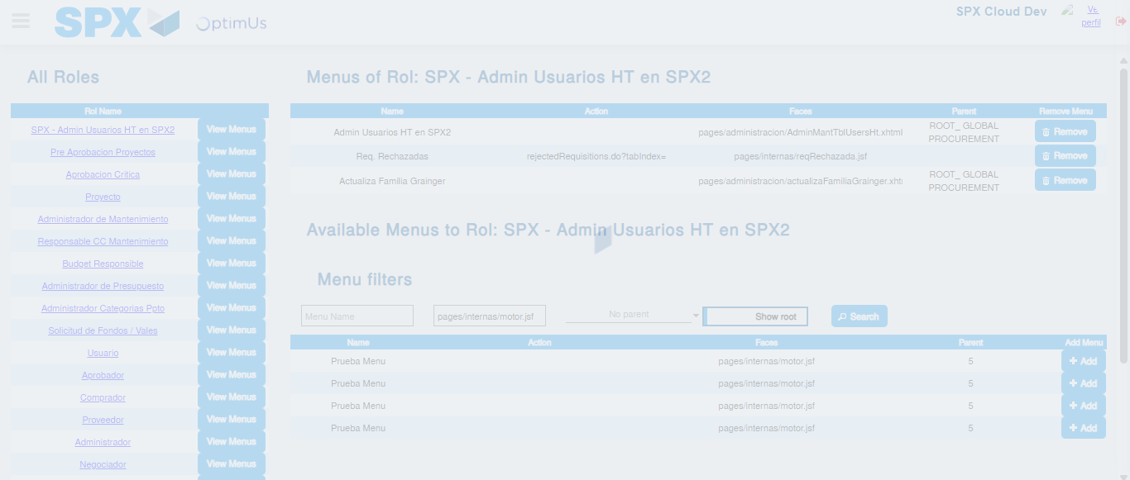Image file-name: QC_Testing-runTestMultipleTimes-dic. 04 2025, 03 38 22 p. m.

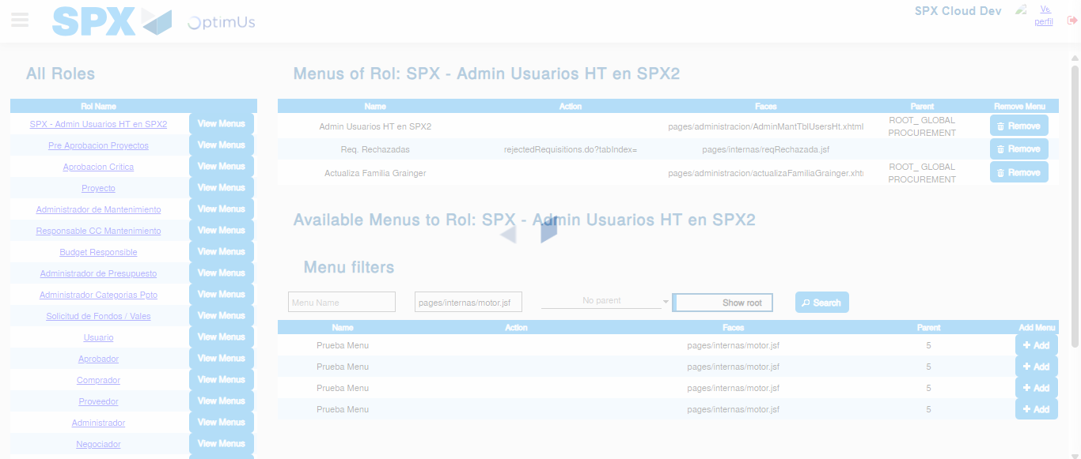Image file-name: QC_Testing-runTestMultipleTimes-dic. 04 2025, 03 38 23 p. m.

